**SQL Queries DIVIYALAKSHMI V**

1.**TABLE**

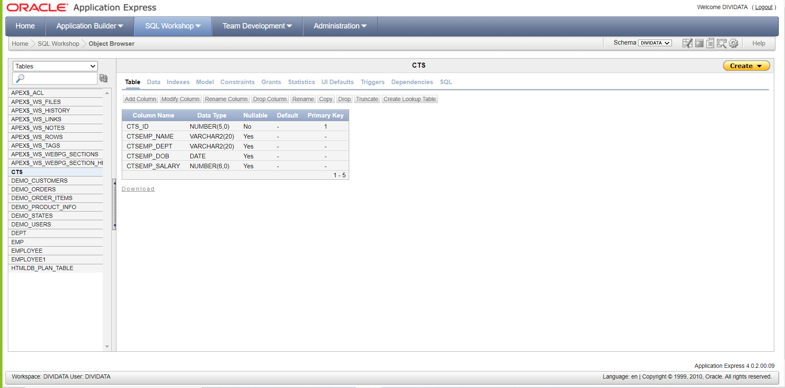

**CREATING A TABLE: CTS**

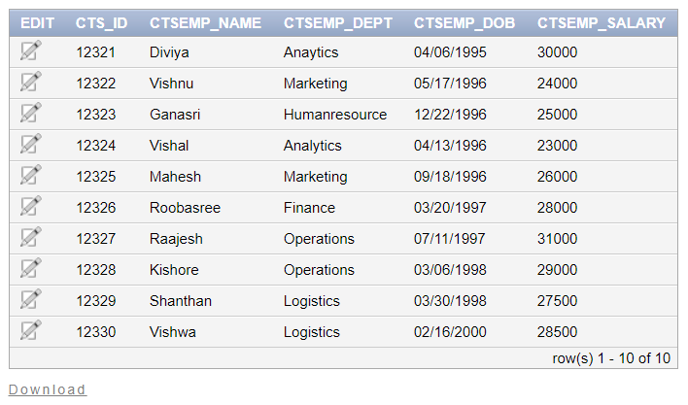

1. **To display intern name, dept and dob**

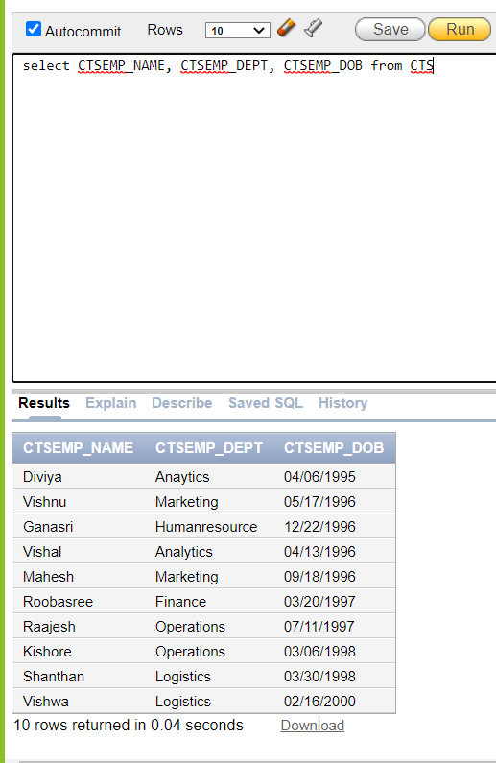

**2.SQL Command using select statement to display the details of employee whose salary is greater than 27000.**

select CTS_ID, CTSEMP_NAME, CTSEMP_DEPT, CTSEMP_DOB, CTSEMP_SALARY from CTS where CTSEMP_SALARY>27000

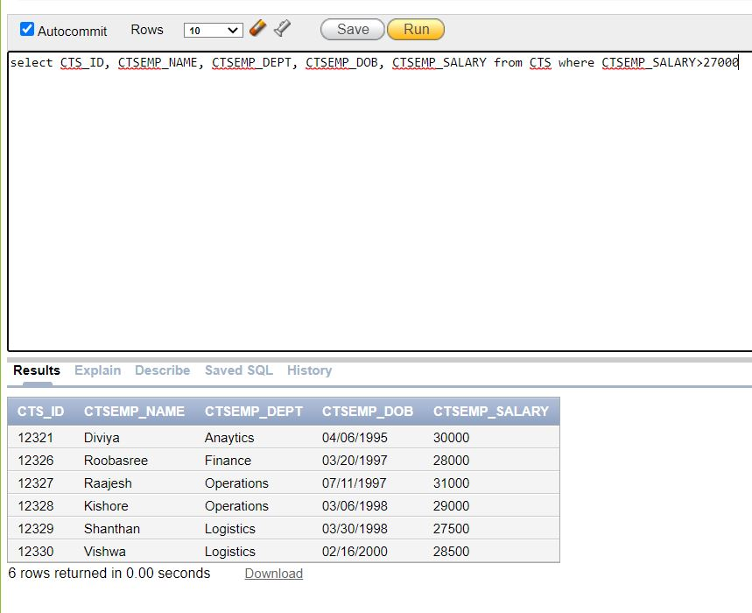

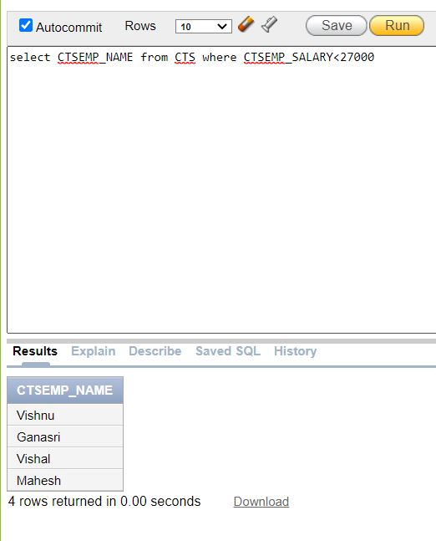

3.**SQL Command using select statement to display the name of employee whose are from “Logistics” department**.

select CTSEMP_NAME from CTS where CTSEMP_DEPT='Logistics'

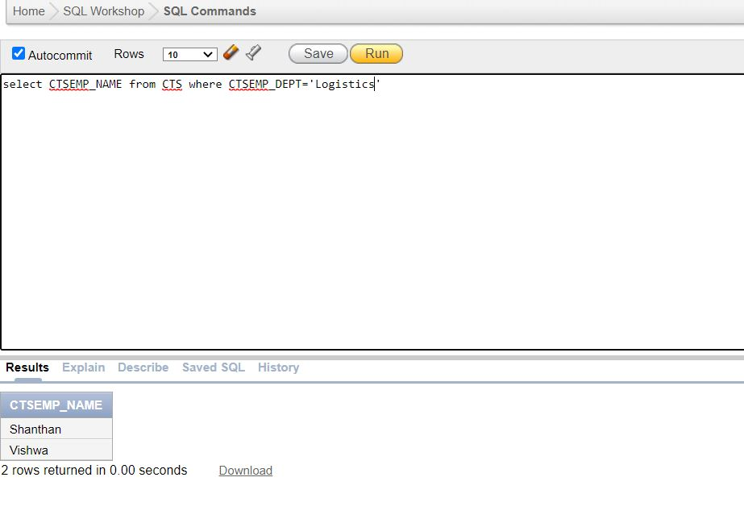4.**SQL Command using select statement to display the details of employee whose are from “Logistics” department.**

select CTS_ID, CTSEMP_NAME, CTSEMP_DOB, CTSEMP_SALARY from CTS where CTSEMP_DEPT='Operations'

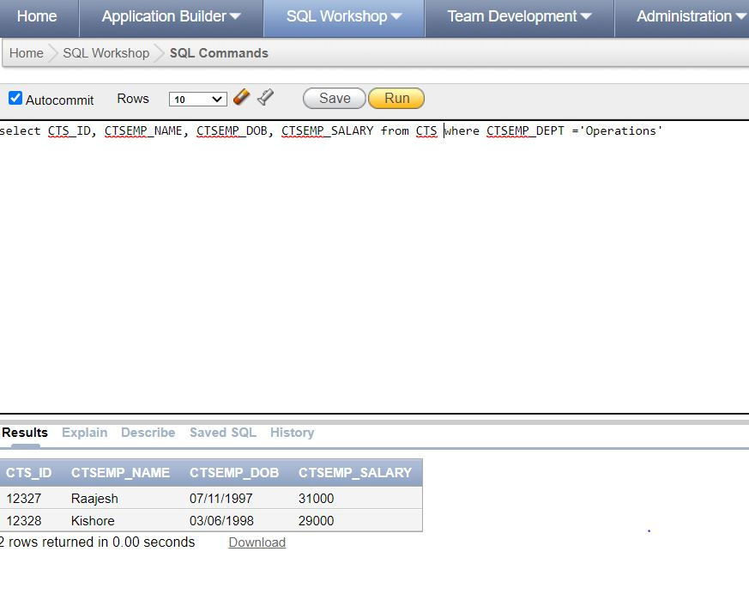

1. **SQL Command for Creating a table – student1**

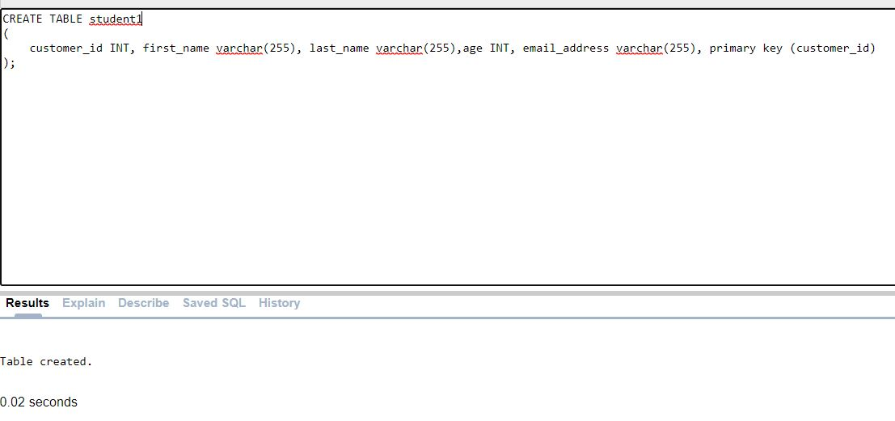

1. **To display the minimum salary using select statement.**

**select min(CTSEMP_SALARY) "The Minimum salary is " from CTS**

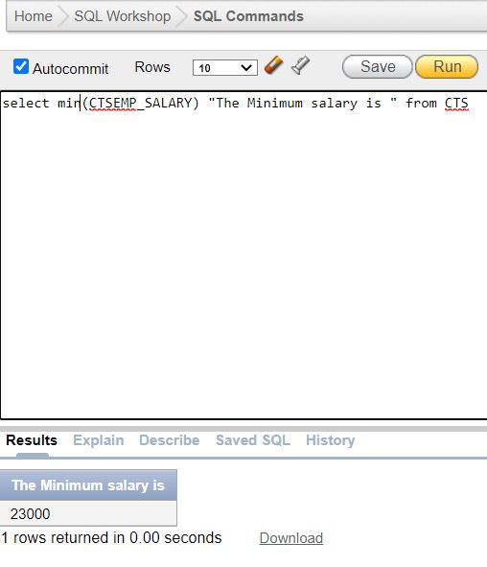

**7.To display the minimum salary using select statement.**

**select max(CTSEMP_SALARY) "The Maximum salary is " from CTS**

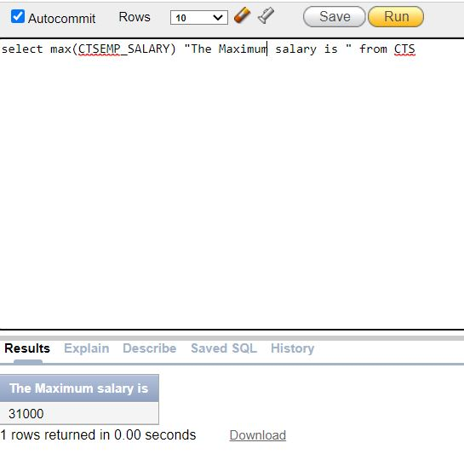

1. **SQL Command using select statement to display the name of interns whose are from “Operations” department.**

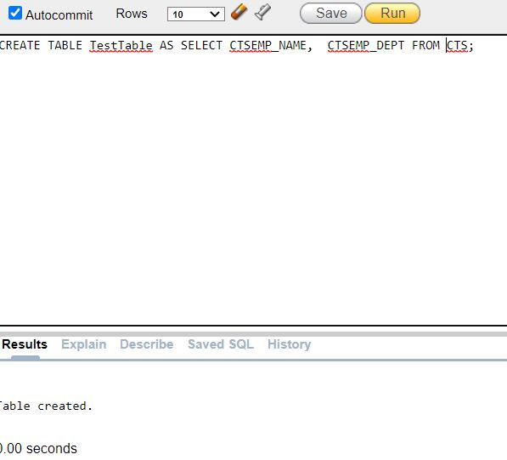

1. **SQL Command for Creating a table – Persons**

**CREATE TABLE Person**

**(**

**PERSON_ID INT, PERSON_EMPNAME varchar(255), PERSON_AGE INT, primary key (PERSON_ID)**

**);**

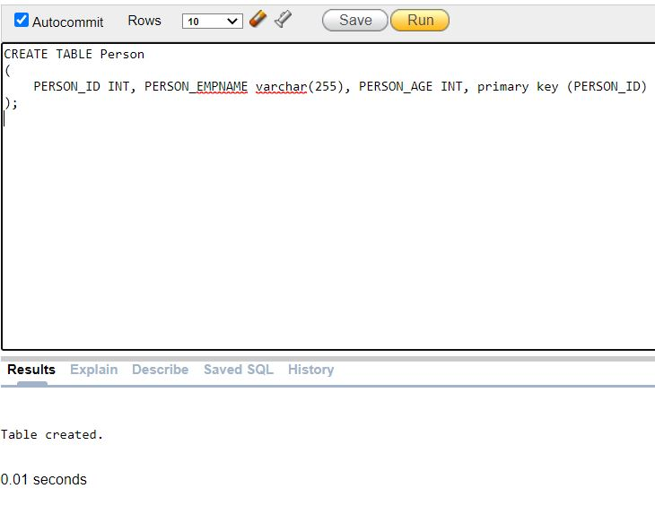

1. **SQL Command to insert a data into Person table**

**INSERT INTO PERSON(PERSON_ID,PERSON_EMPNAME,PERSON_AGE) VALUES('1234','Arun','22');**

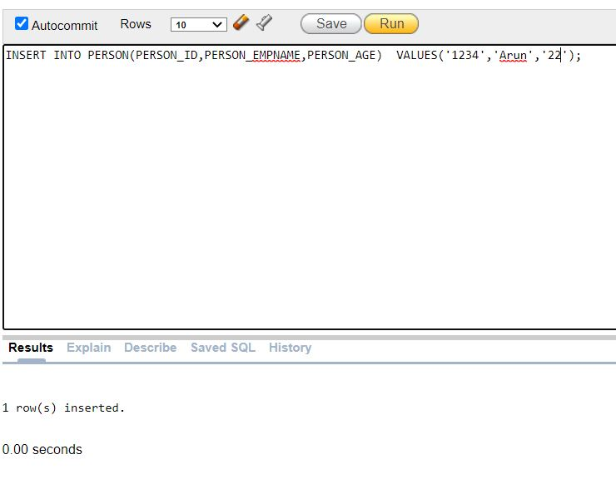

1. **SQL Command to insert a data into customers table**

**insert into customers(customer_id,first_name,last_name,email_address,number_of_complaints) values('12321','Diviya'’lakshmi’,'diviya@gmail.com','1')**

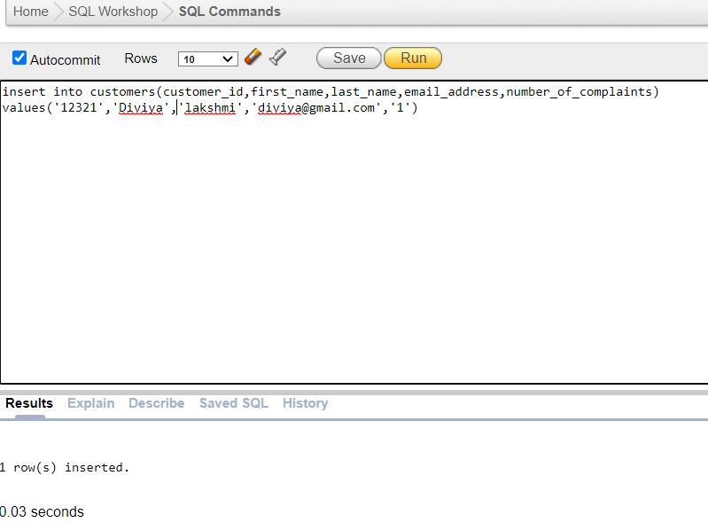

1. **SQL Command to insert a data into customers table**

**insert into customers(customer_id,first_name,last_name,email_address,number_of_complaints)**

**values('12324','Arun','Shiva','arun@gmail.com','0')**

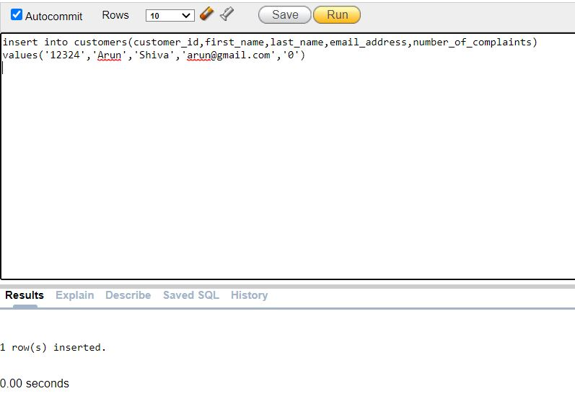

**Inbuilt Functions usage:**

1. **SQL command to round of the value 5.63**

**Select ceil(5.63) from dual**

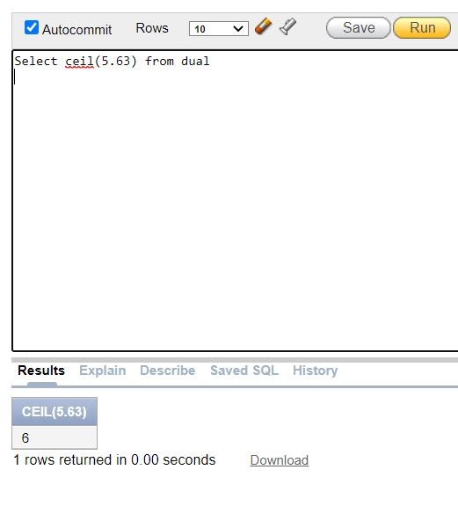

1. **SQL Command to display the value without decimals**

**Select trunc(5.63) from dual**

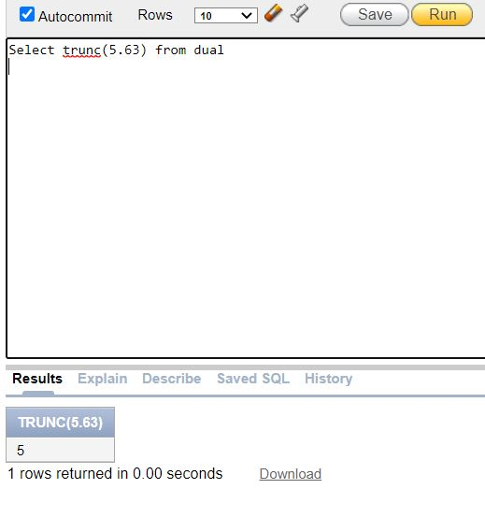

1. **SQL Command to display the sum of all the interns**

**select sum(CTSEMP_SALARY) from CTS**

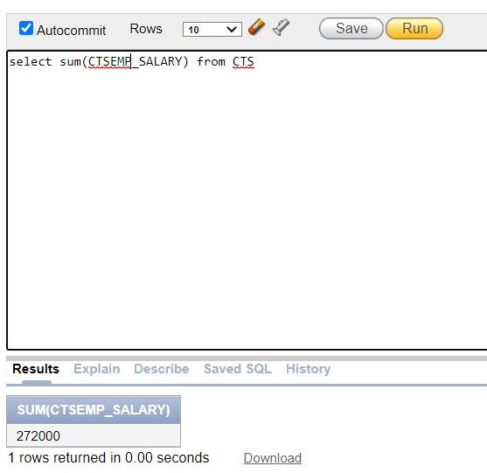

1. **SQL Command to display the count of all the employee ID data stored in the employee table.**

**select count(CTS_ID) from CTS**

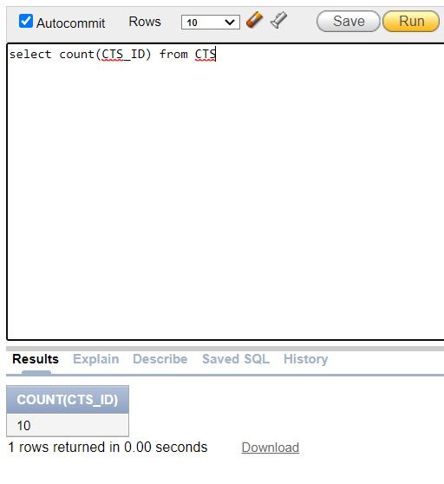

1. **SQL Command to display the system date**

**select sysdate from dual;**

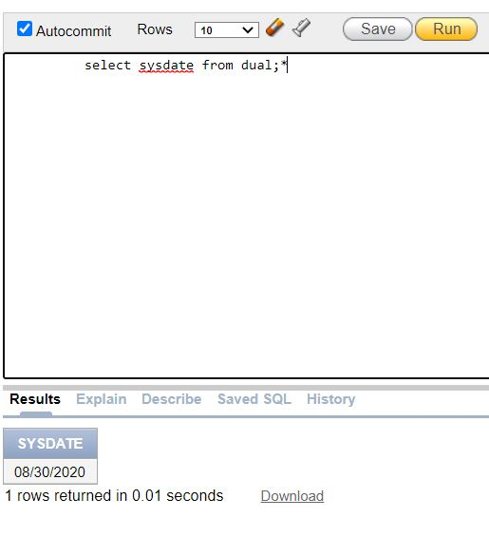

1. **Using Floor Function**

**select floor(25.87666) from dual;**

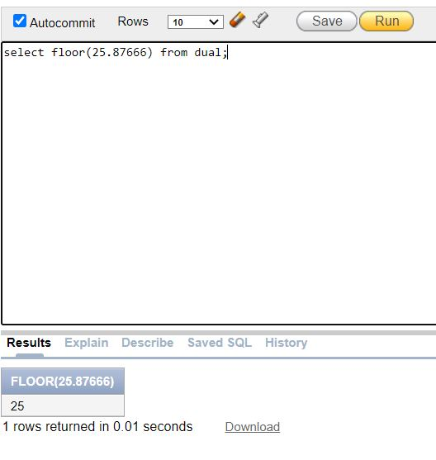

1. **SQL Command to display the length of all the employee names**

**select length(CTSEMP_NAME) from CTS**

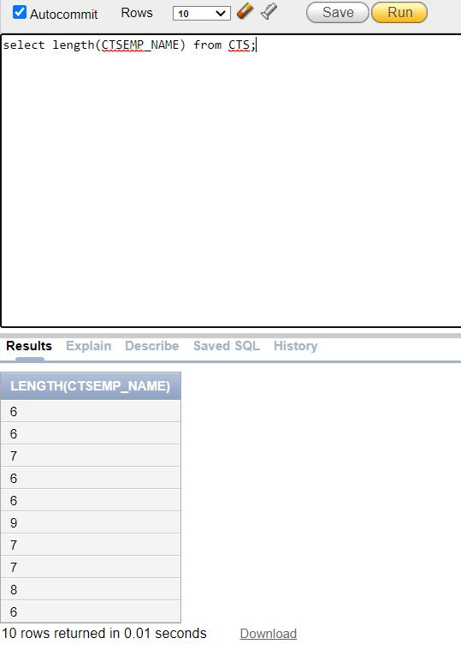

1. **SQL command to round of a number to 2 digits.**

**SELECT ROUND(137.55456, 2) from dual**

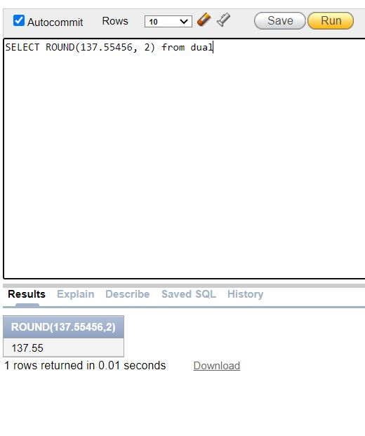

1. **SQL Command to display the power of 40**

**SELECT power(50, 3) from dual**

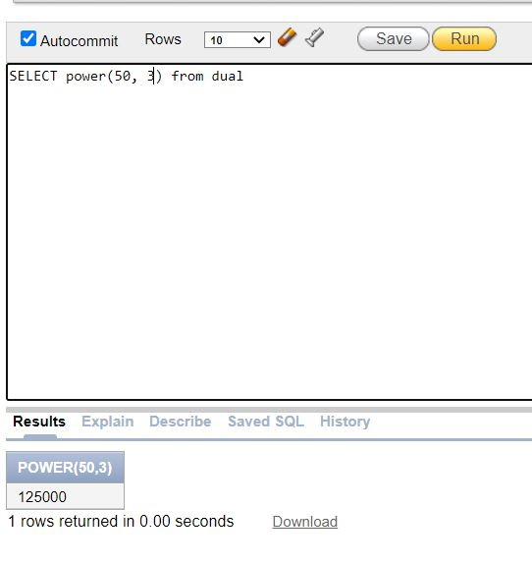

1. **SQL Command to display the exponential value of 1.**

**SELECT EXP(5) from dual;**

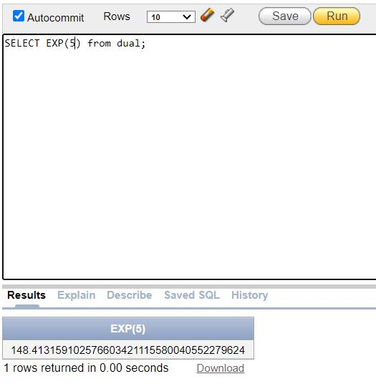

1. **SQL Command to display the average of marks.**

**SELECT AVG(CTSEMP_SALARY) FROM CTS**

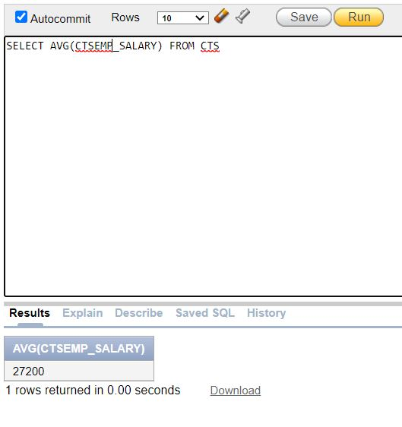

1. **SQL Command to display the square root of 225.**

**SELECT SQRT(225) from dual**

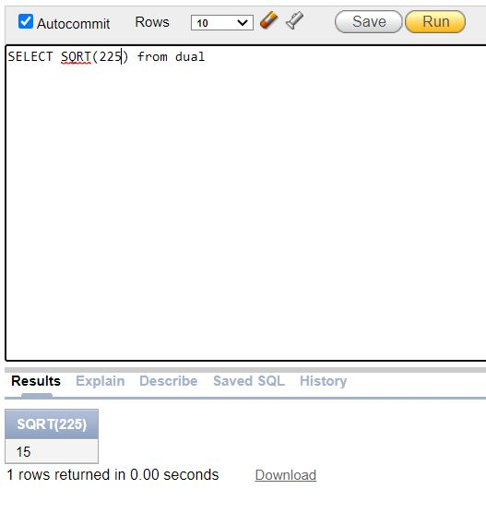

1. **SQL Command using “=” operator.**

**SELECT CTSEMP_SALARY FROM CTS WHERE CTSEMP_SALARY=24000**

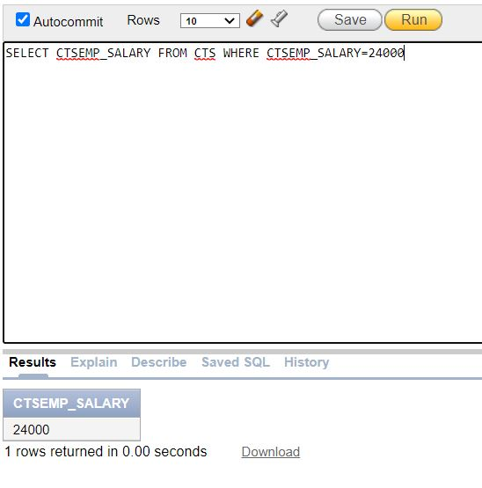

1. **To display the salary of each employee**

**SELECT 'Salary of ' || CTSEMP_NAME || ' is ' || CTSEMP_SALARY from CTS**

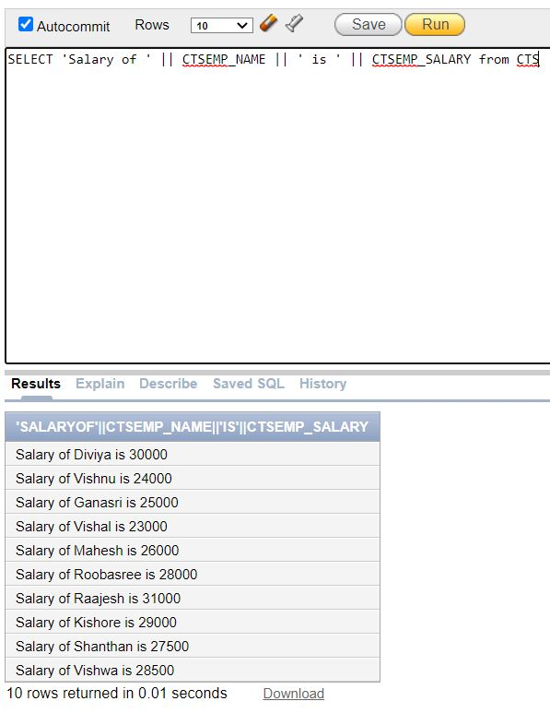

1. **To display the average value of an intern using trunc and average function.**

**SELECT trunc(avg(CTSEMP_SALARY),2) from CTS**

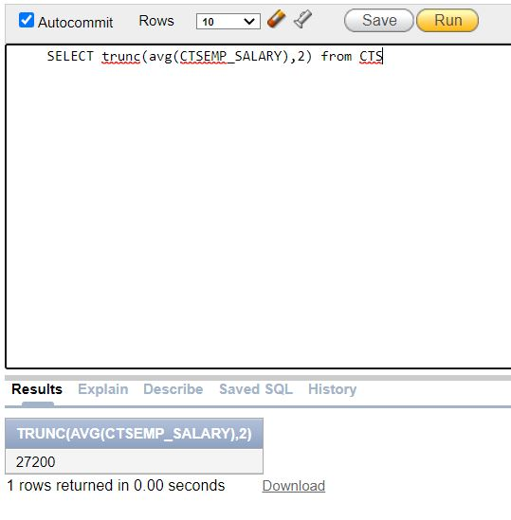

1. **SQL Command to update the intern data**

**UPDATE CTS set CTSEMP_SALARY= 26000 where CTSEMP_NAME='Vishnu'**

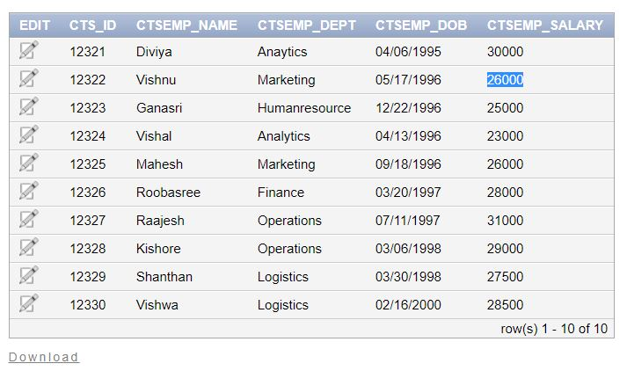

1. **SQL Command to drop a table.**

**DROP TABLE TESTTABLE**

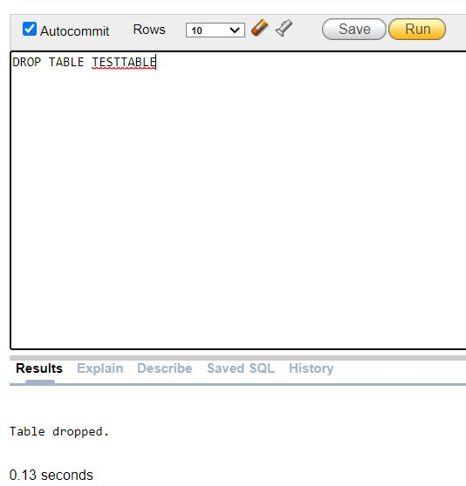

1. **SQL Command to remove all the data from the table by keeping the table CTS**

**TRUNCATE TABLE CTS**

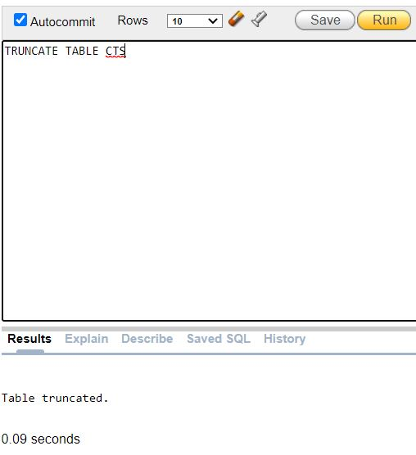

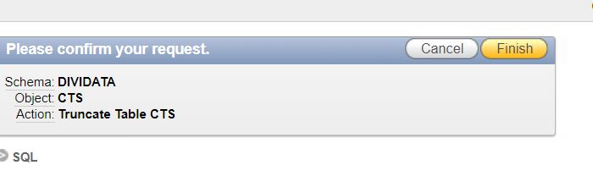

**31.Arithmetic Operations**

**SELECT (20+50+30/20*60*70-40*10*10) from dual**

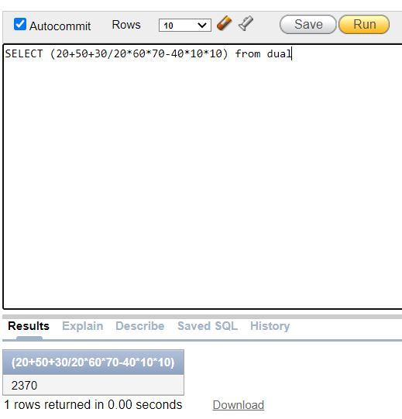

**32.Relational Operators**

**SQL Command to display the salary of interns whose salary is <= 25000**

**SELECT CTSEMP_SALARY FROM CTS WHERE CTSEMP_SALARY<=25000**

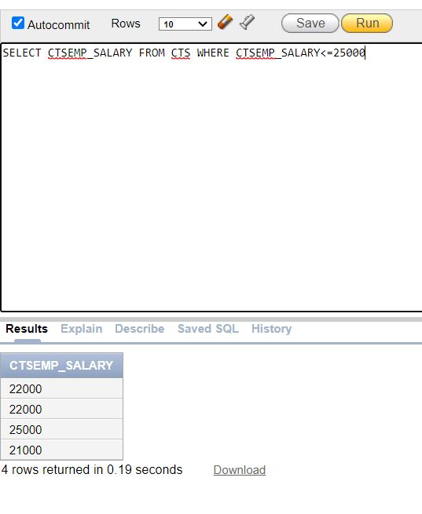

1. **SQL Command to display the salary whose salary is >= 20000.**

**SELECT CTSEMP_SALARY FROM CTS WHERE CTSEMP_SALARY>=20000**

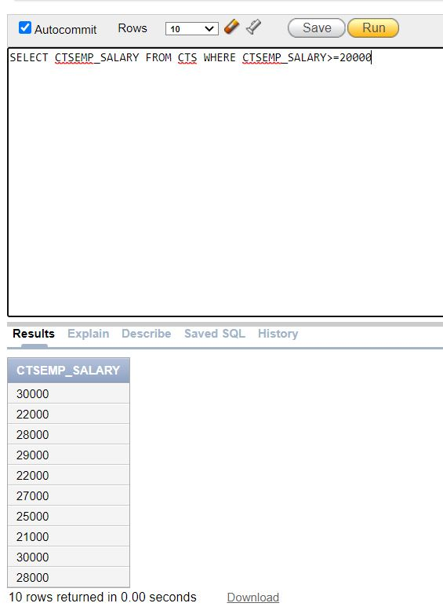

1. **SQL Command to display the salary of interns, intern name whose salary is = 27000.**

**SELECT CTSEMP_NAME,CTS_SALARY FROM CTS WHERE CTSEMP_SALARY=27000**

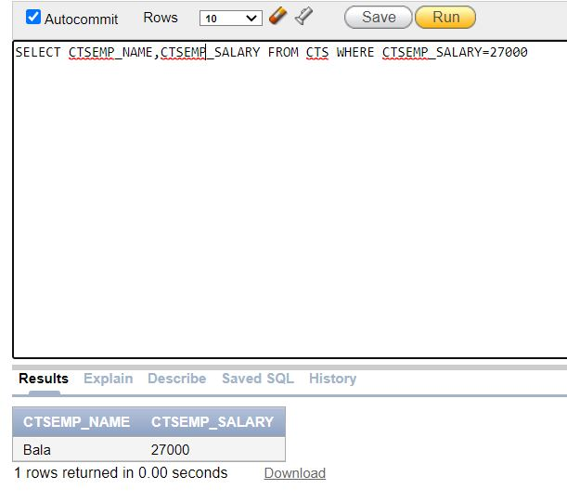

1. **SQL Command to update an employee name**

**UPDATE CTS set CTSEMP_NAME='Dilip' where CTSEMP_NAME='Aravind'**

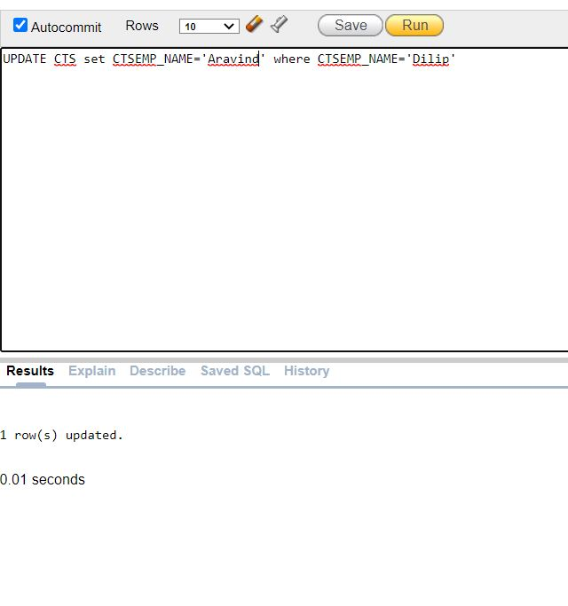

1. **SQL Command to update date of birth of an intern.**

**update CTS set CTSEMP_DOB=TO_DATE('03/12/1997') where CTSEMP_ID='12325'**

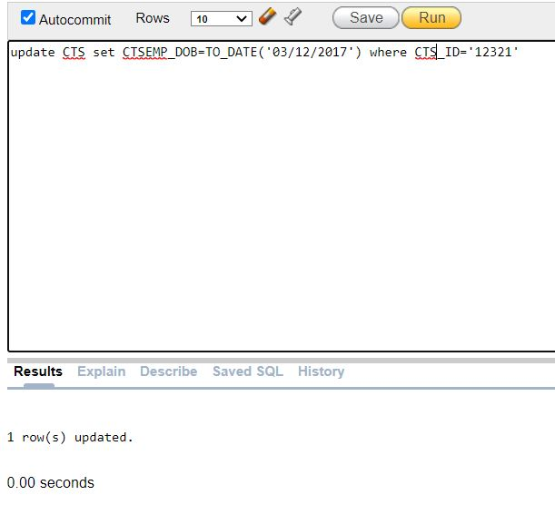

1. **SQL Command to order the names in ascending order.**

**SELECT * FROM CTS ORDER BY CTSEMP_NAME ASC**

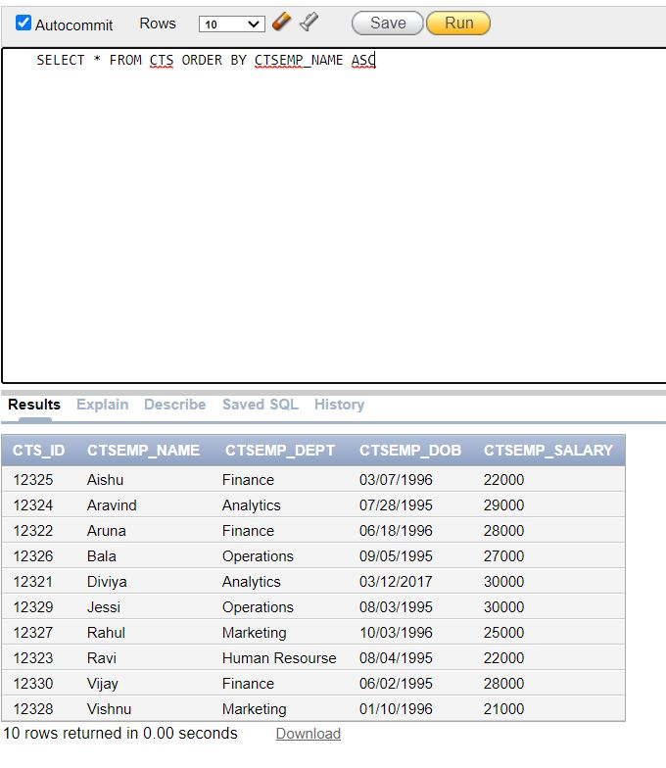

1. **SQL Command to order the departments in descending order.**

**SELECT * FROM CTSEMP ORDER BY CTSEMP_DEPT DESC**

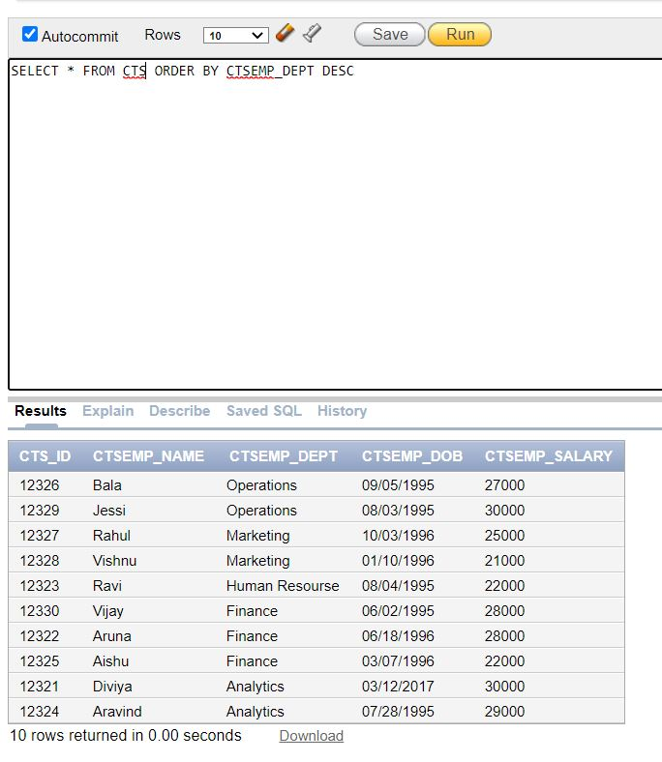

1. **Grouping the data.**

**SELECT CTSEMP_DEPT CTSEMP_SALARY FROM CTSEMP GROUP BY CTSEMP_DEPT**

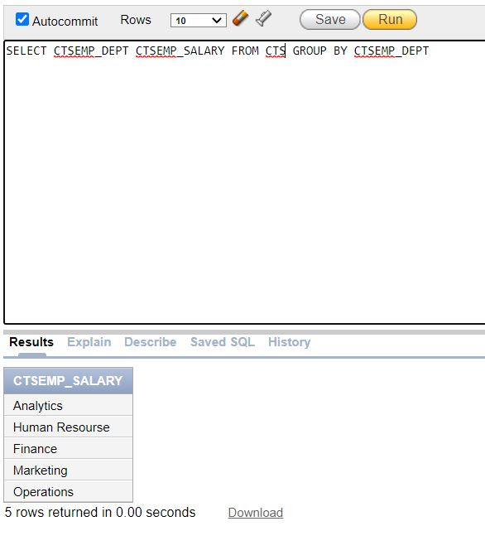

1. **To print the salary**

**SELECT 'The Salary of ' || CTSEMP_NAME || ' from ' || CTSEMP_DEPT || ' Department is ' || CTSEMP_SALARY FROM CTS**

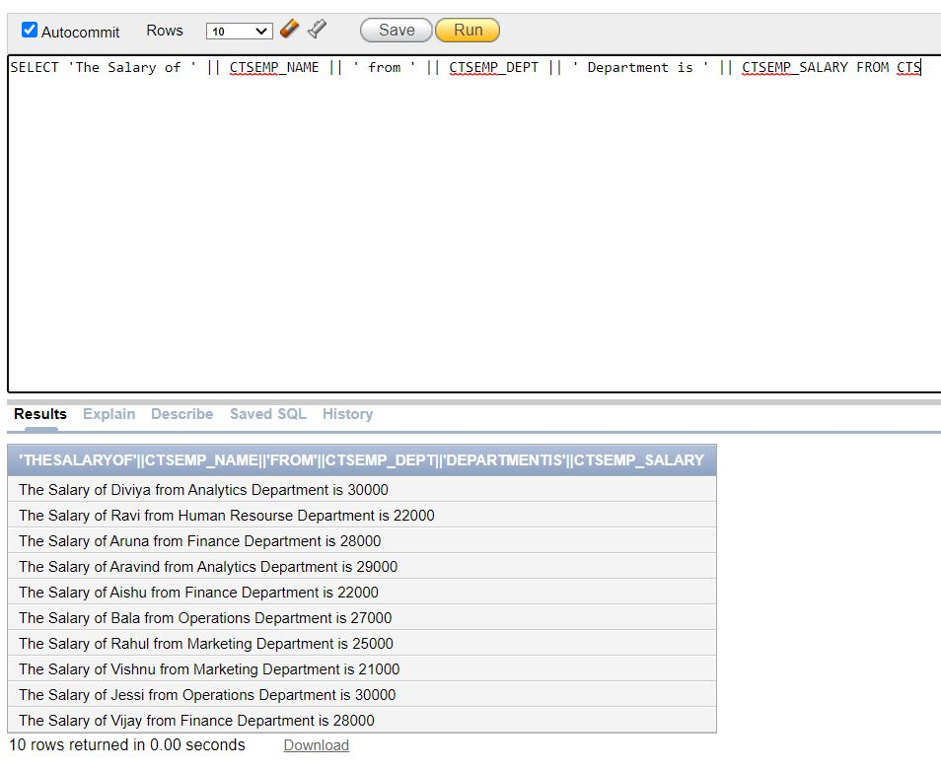

**41.SQL Command to insert a column in CTS table.**

**ALTER TABLE CTS ADD CTS_DATA NUMBER(5)**

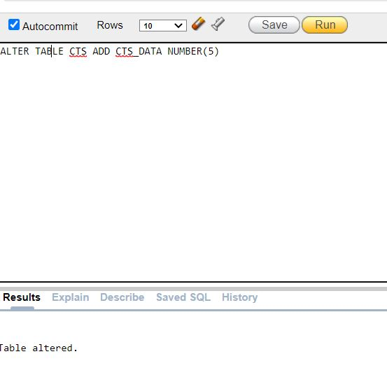

**42.SQL Command to DROP a column – CTS Salary in CTS table.**

**ALTER TABLE CTS DROP COLUMN CTS_SALARY**

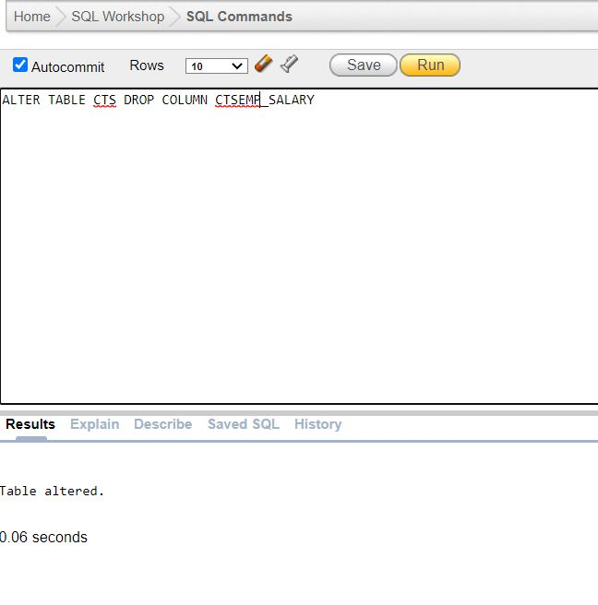

1. **To modify the table CTS.**

**ALTER TABLE CTS MODIFY CTS_EMPNAME VARCHAR(20)**

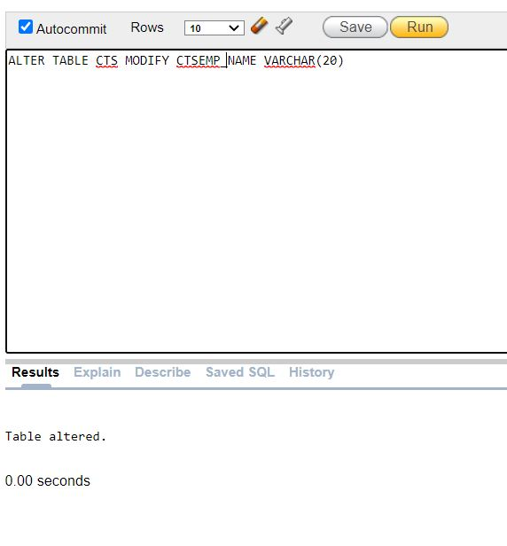

**45.SQL Command using select statement to display the name of employee whose name is “Diviya”.**

**select CTS_NAME from CTS where CTSEMP_NAME='Diviya'**

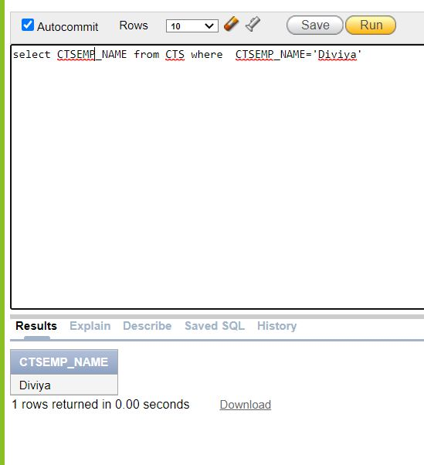

**46.SQL Command for Creating a table – KCT**

**CREATE TABLE KCT**

**(**

**KCT_ID INT, KCT_STUDENTNAME varchar(255), KCT_DEPT varchar(255), KCT_STAFFNAME varchar(20), primary key (KCT_ID)**

**);**

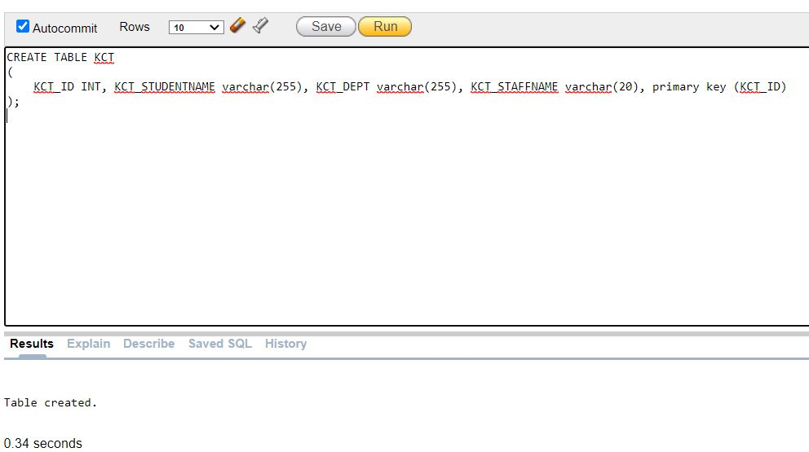

1. **SQL Command to insert a data into the table KCT.**

**insert into KCT(KCT_ID,KCT_STUDENTNAME,KCT_DEPT,KCT_STAFFNAME)**

**values('12235','Shekar','Analytics','Vishwa')**

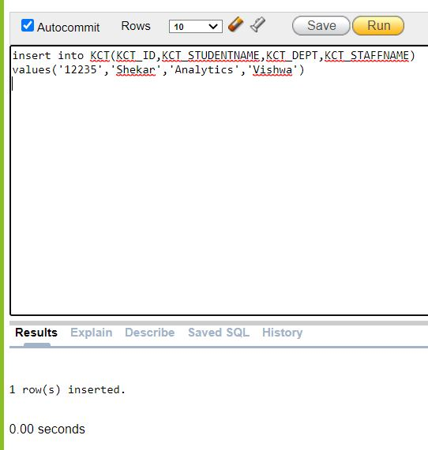

1. **SQL Command to delete all the data from KCT.**

**DELETE FROM KCT**

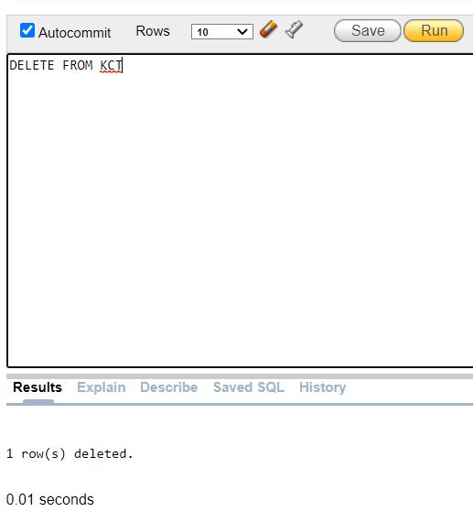

1. **Using CONCAT**

**SELECT CONCAT (CONCAT (CTSEMP_NAME, 's date of birth is '),CTSEMP_DOB) FROM CTS;**

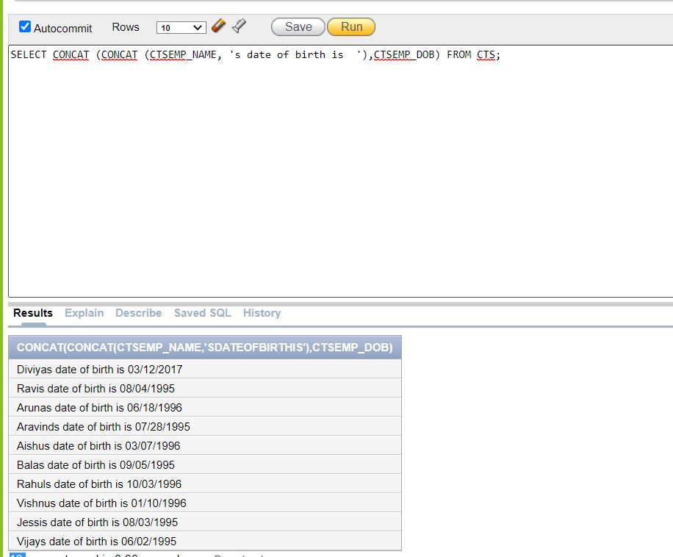

1. **SQL Command to display the minimum value of an employee**

**select MIN(CTSEMP_S) from CTS**

